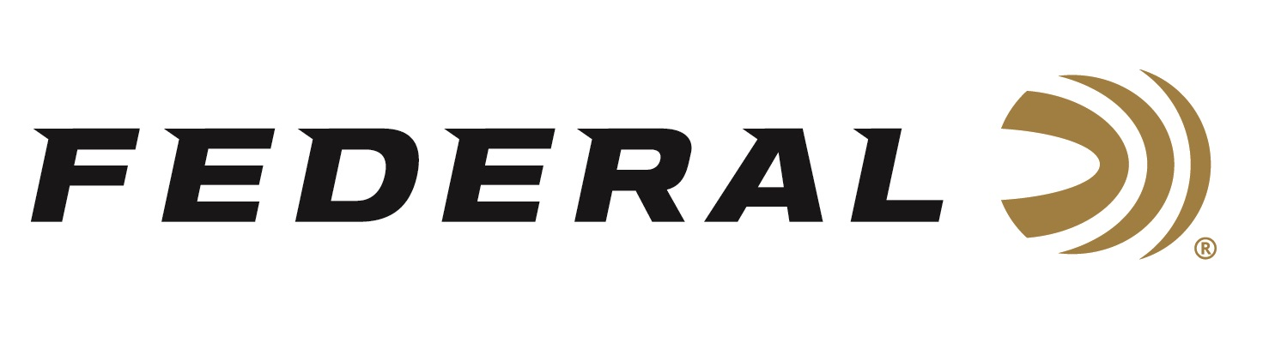

FOR IMMEDIATE RELEASE

Federal Adds 28-Gauge to Its Popular Black Cloud Waterfowl Ammunition Product Line

ANOKA, Minnesota – September 21, 2023 – Federal Ammunition adds two 28-gauge, 3-inch, ¾-ounce loads in shot size No. 3 or 4 to its Black Cloud product lineup. More than a decade ago, Black Cloud changed the definition of performance for steel waterfowl loads. That revolution continues today with Black Cloud 28-gauge, 3-inch offerings that redefine the capability of sub-gauges.

Black Cloud | Federal Premium

“When first approached for developing a 28-gauge, 3-inch waterfowl load, Black Cloud was the obvious first choice out of all our product lines,” said Federal Shotshell Product Director Dan Compton. “Black Cloud’s technology blend of FLITESTOPPER Steel, zinc plated Premium steel and FLITECONTROL FLEX wad really shines in these smaller but highly effective loads. They pattern very tight and hit hard. We are extremely happy with the results.”

Like all Black Cloud loads, the new 28-gauge loads use the FLITECONTROL FLEX wad which delivers better pattern density and consistency through both ported and standard waterfowl chokes.

“Our FLITESTOPPER steel pellets make up a full 40 percent of the payload, and really help the terminal performance of any sub-gauge,” said Compton. “A raised cutting ridge encircling the exterior gives the pellets an unparalleled ability to slice through feathers and flesh. These specialized pellets create significantly larger wound channels than standard round pellets or other designs, devastating game on impact.”

Other features include: 1,400 fps muzzle velocity provides ample downrange energy; High-performance primer and clean-burning, temperature stable propellant; Payload of 40 percent FLITESTOPPER steel pellets and 60 percent Premium steel; Plated head inhibits corrosion; Sealed crimp defeats moisture in extreme conditions; 25-round boxes; MSRP: $40.99.

For more information on all products from Federal or to shop online, visit www.federalpremium.com.

Press Release Contact: JJ Reich
Senior Manager – Press Relations
E-mail: VistaPressroom@VistaOutdoor.com

About Federal Ammunition
Federal, headquartered in Anoka, MN, is a brand of Vista Outdoor Inc., an outdoor sports and recreation company. From humble beginnings nestled among the lakes and woods of Minnesota, Federal Ammunition has evolved into one of the world's largest producers of sporting ammunition. Beginning in 1922, founding president, Charles L. Horn, paved the way for our success. Today, Federal carries on Horn's vision for quality products and service with the next generation of outdoorsmen and women. We maintain our position as experts in the science of ammunition production. Every day we manufacture products to enhance our customers' shooting experience while partnering with the conservation organizations that protect and support our outdoor heritage. We offer thousands of options in our Federal Premium and Federal® lines-it's what makes us the most complete ammunition company in the business and provides our customers with a choice no matter their pursuit.

